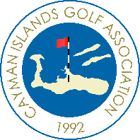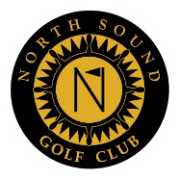
Cayman Islands JUNIOR ChampionshipS
for golfers aged 18 years and under
Trophies sponsored by Jika Africa
September 30th and October 1st 2017 – North Sound Golf Club.

Boys Champion: ANDREW JARVIS
Girls Champion: HOLLY MCLEAN
9 Hole Champion: DANNY LYNE

CHAMPIONSHIP
BOYS – 36 HOLES BLUE TEES
 |  | ROUND 1 | ROUND 2
ANDREW JARVIS |  | 64 | 75 | 139
JUSTIN HASTINGS |  | 72 | 69 | 141
AARON JARVIS |  | 75 | 72 | 147
ANDREW HASTINGS |  | 89 | 84 | 173
JOE PURTON |  | 86 | 92 | 178
TOM DICKENS |  | 91 | 88 | 179
JAMES BOULD |  | 98 | 94 | 192
TODD PURTON |  | 101 | 95 | 196
CHAMPIONSHIP
GIRLS - 36 HOLES RED TEES
 |  | ROUND 1 | ROUND 2
HOLLY MCLEAN |  | 79 | 78 | 157
LAUREN NEEDHAM |  | 86 | 84 | 170
9 HOLE CHAMPIONSHIP – RED TEES

DANNY LYNE | 42
SAM MCLEAN | 46
LUKE DODSON | 50
TABITHA HAWKINS | 50
ZACH BROOKS | 52
BEN CROUCHER | 54
CIAN ANDERSON | 56
BETH WALTON | 57
JOSH DICKENS | 64

